**NIT2122 Server Administrator Lab 6 – Practical Activity**

# Activity 6-1 Configure DNS Zones

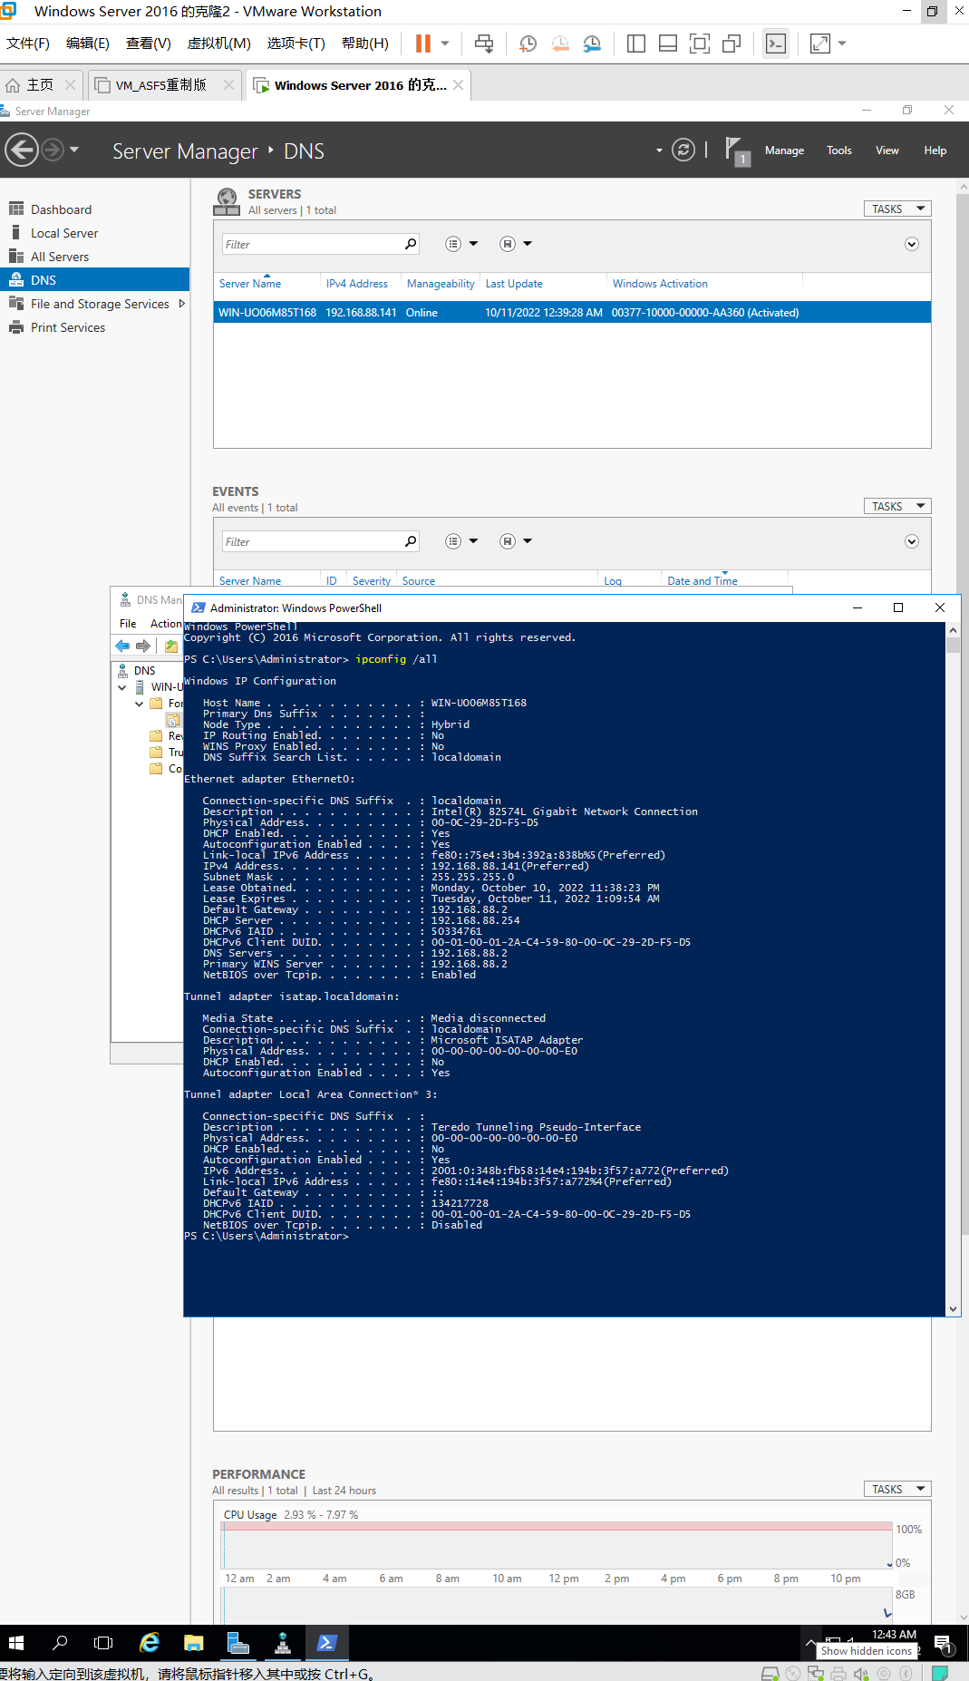

**Figure config /all**

1. Remote connect to EC2 instance you created for Activity 3 (named NIT2122_Instance_1) if you use AWS Account. *Otherwise, start windows server 2016 on Virtual Box Or vSphere*.
2. Make sure you installed DNS Server (Activity 3-1) and AD DS (Activity 3-2).
3. Open Server Manager, and select DNS from Tools dropdown menu.
4. Expand your local domain (such as EC2AMAAZ-HFJFREC). Right-click the Forward Lookup Zones node, and then Click New Zone.
5. In the New Zone Wizard, on the Welcome To The New Zone Wizard page, click Next.
6. On the Zone Type page, select Primary Zone, and then click Next.
7. On the Active Directory Zone Replication Scope page, default to second option. Click Next.
8. On the Zone Name page, in the Zone name box, type the zone name with your student id. For example, type ‘*s123456.com*’. Click Next.

***. Please replace s123456 with your student id***

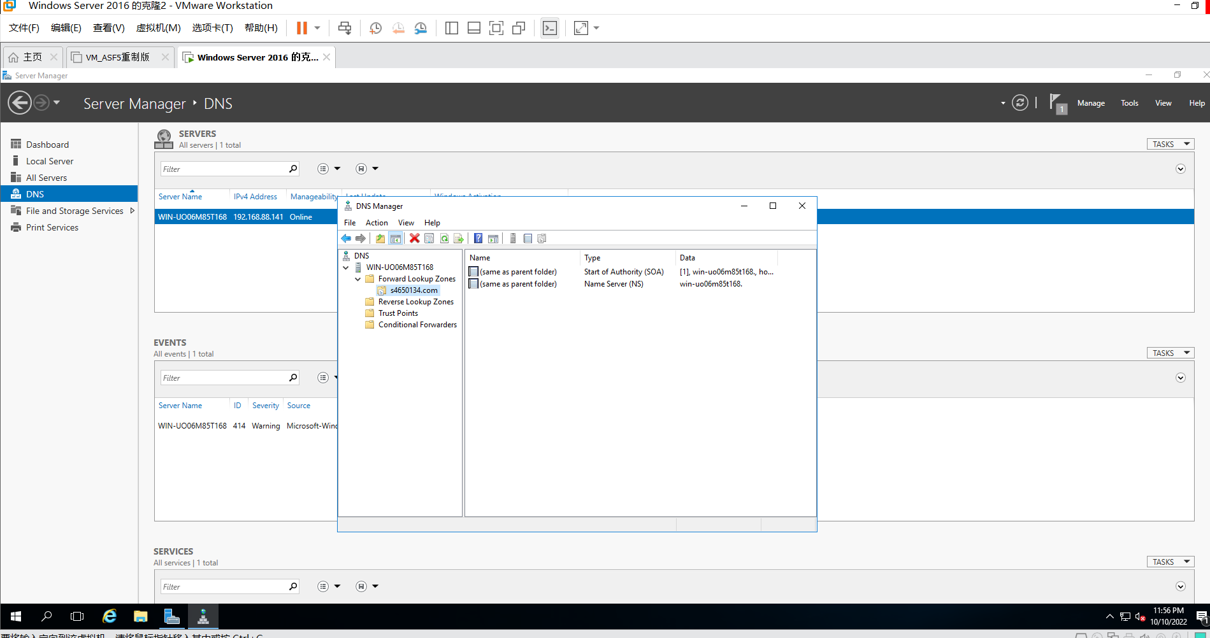

***Figure s4650134.com***

1. On the Dynamic Update page, choose Allow Only Secure Dynamic Updates (Recommended For Active Directory).
2. On the Completing The New Zone Wizard page, click Finish.

# Activity 6-2 Configure IP Address

## - AWS EC2 instance with Specific Security Groups (If you use AWS)

1. Go to EC2 dashboard, create new instance with Windows Server 2016 base (named NIT2122_Instance_2). In this progress, please rename your security group with your student id, such as s123456_security.
2. Configure rules for this security.
   * Click Edit. Click Add Rules. Select RDP (Type), TCP (Protocol), 3389 (Port Range), Anywhere (Source).
   * Click Add Rules. Select Custom ICMP Rule - IPV4 (Type), Echo Request (Protocol), N/A (Port Range), Anywhere (Port Range).
   * Click Add Rules. Select Custom ICMP Rule - IPV4 (Type), Echo Reply (Protocol), N/A (Port Range), Anywhere (Port Range).
3. Go to EC2 dashboard, select new created instance.

. Record public and private IPv4 address in the Description Tab (Bottom), such 171.31.3.220 for private IPv4 address.

1. Remote Connect to this instance.
2. Click Start and find Windows Firewall with Advanced Security.
3. Click Inbound Rules. Right Click ‘File Printer Sharing (Echo Request – ICMPv4- In)’ for Domain. Click Enable.

## Virtual Box Version (If you use your own laptop)

1. Create a new virtual machine with Windows Server 2016, named NIT2122_Instance_2.
2. Configure static IP address, and restart the server

. Record your IP address

## vSphere Version (If you use VU provided vSphere)

1. Open Powershell
2. Type ‘*ipconfigure*’, and get your local IP address

# Activity 6-3 Create Host on Primary Zone

1. Remote connect to first server (*e.g.*, NIT2122_Instance_1). If you use vSphere, then it only has one server.
2. Go to Server Manager, and Select DNS from Tools menu.
3. Expand Forward Lookup Zones.
4. Right-Click your created Zones (s123456.com) in Activity 6-1. Select New Host (A or AAAA).
5. Type mail in Name field. Type IPv4 address (the IPv4 address you got from Activity 6-2) into IP address field. Click Add Host. The successful created Wizard will be shown. Click Close.

# Activity 6-4 Ping Test

1. Open Windows PowerShell
   * If you use AWS, then open power shell in the instance: NIT2122_instance_1.

-

1. Type ‘*ping mail.s123456.com*’.

. Record the result.

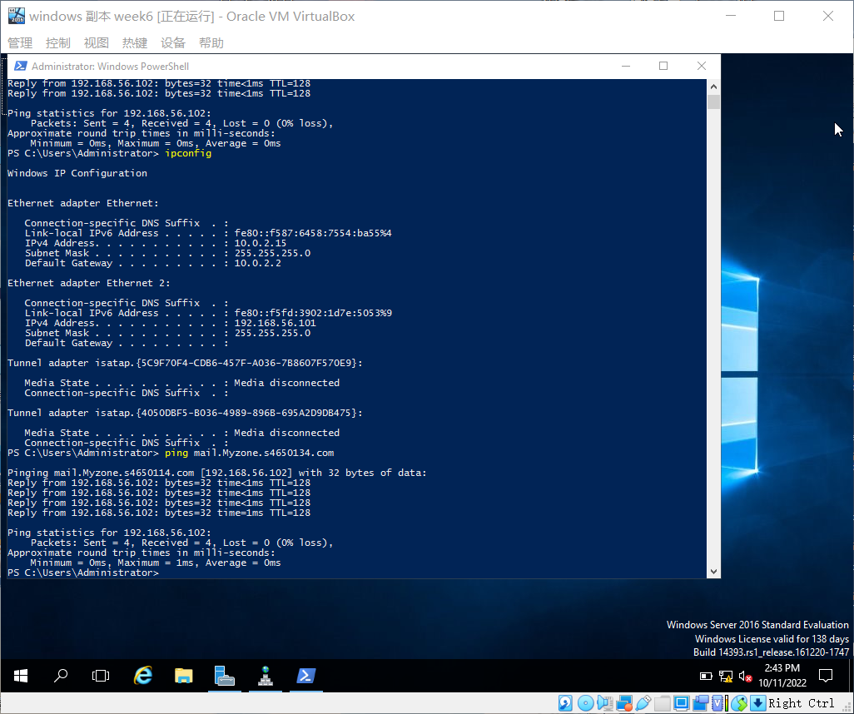

**Figure result**

**Mark Standard:**

*If the record screen shows following information when you ping mail.s123456.com: Packets: Sent = 4, Received = 4, Lost = 0 (0% loss), then you pass the test.*